# THEN AND NOW: Wattie House — majestic, endearing and rock solid

With flat edge field stones that went all the way to the roof line and uncut stones used for the cellar walls, Wattie House, built in 1872, was built to last

Deb Exel

Jun 13, 2021 12:00 PM

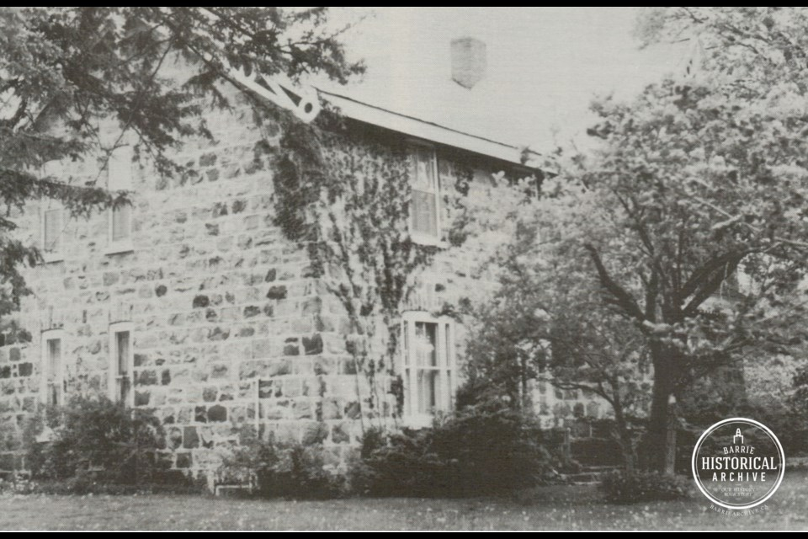

Strathaven, or as most locals refer to it: Wattie House. (c1980s Vespra Township Historical Committee)

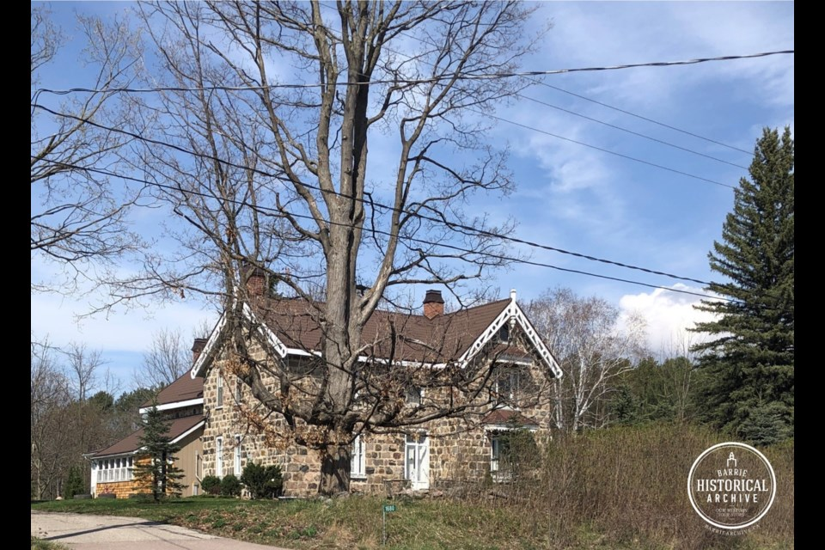

Strathaven, or as most locals call it, Wattie House, 2021.

[*Expand*](https://www.barrietoday.com/then-and-now/then-and-now-wattie-house-majestic-endearing-and-rock-solid-3870340)

This ongoing series from Barrie Historical Archive curator Deb Exel shows old photos from the collection and one from the present day, as well as the story behind them.

There’s actually some dispute over the name. Some believe the house was actually called Stratheden …. like in Strathdon, Aberdeen, Scotland where the home’s ancestors came from. Most locals would probably refer to it as the [Wattie House](https://www.barriearchive.ca/piece/the-wattie-house-was-built-in-1872-and-was-called-strathaven/?utm_source=barrietoday.com&utm_campaign=barrietoday.com%3A%20outbound&utm_medium=referral" \t "_blank).

Charles Forbes Wattie (the first) and his wife Euphemia McHardy settled in Vespra when they came to Canada from Scotland. Their son Charles Forbes Wattie (the second) and his wife Isabella Orok purchased 100 wooded acres on Concession 7 (now Wilson Drive) from William Ardagh in 1862.

The Minesing Road (now Highway 26) would cut through their property, creating a wedge-shaped section of land where they decided to build their home. During the construction of their cabin, the Watties built a rough shelter around a large stone – this rock would later become the back of the fireplace in their log home. The stone is still in its original spot on the property.

While Charles and Isabella lived in the shelter, building their cabin, Indigenous peoples camped near the springs at the south end of their farm.

In 1872, the Watties started building the current stone house, designed by James Spence, Wattie’s brother-in-law, who worked for the Department of Railways (and coincidently also worked on the parliament buildings in Ottawa).

The field stones for the house were gathered from the Wattie property and hand cut to form the 18” thick walls. The flat edge field stones went all the way to the roof line, with uncut stones used for the cellar walls. This house was built to last.

It was a remarkable home inside and out – it was constructed with ducts for central heating, built-in closets, a section in the basement large enough to hold a whole supply of wood for the winter, 15” window sills, beautiful woodwork throughout, plaster mouldings in the dining room, hall and parlour, wooden canopies over the front windows, gingerbread along the eaves, and the most fascinating feature of all: a key stone over the front door carved in the likeness of Charles Wattie.

Charles and Isabella’s son, Charles (the third) and his wife Ella Leadly also lived on the farm. Wattie was Reeve from 1913-1922.

And then it became known as the Channen House.

E.C. (Ted) Channen and his wife Ann had expressed interest in purchasing Strathaven in 1945. An agreement for the sale of the house was reached, but the night before the deal was to be signed, Mr. Wattie died. The house passed to Wattie’s sister Belle upon his death, but she honoured the original arrangement with the Channens and the sale went through.

Ted (E.C. Channen) was employed as a clerk at CNR in [Allandale](https://www.barrietoday.com/columns/then-and-now/then-and-now-allandale-station-2357183). His father Henry Charles (H.C.) Channen, had a grocery store at 148 Dunlop Street East, about where Bayshore Landing is today.

In 1922, H.C. decided to retire and arranged to sell his business to J.A.R. Cameron, a Bradford Street grocer. The plan was that A. Meekums, who had bought the Cameron store and house at [151 Bradford Street](https://www.barriearchive.ca/piece/former-jr-guest-grocer-building-now-the-site-of-the-midway-diner-on-the-corner-of-bradford-and-john-streets/?utm_source=barrietoday.com&utm_campaign=barrietoday.com%3A%20outbound&utm_medium=referral) earlier that year, would continue to operate there, while Cameron would take over the Channen location. A week after announcing the change in ownership, Channen and Cameron cancelled their deal.

Ted and Ann raised their family in [Strathaven](https://www.barriearchive.ca/piece/the-wattie-house-strathaven-was-built-in-1872-and-is-located-at-highway-26-and-wilson-drive/?utm_source=barrietoday.com&utm_campaign=barrietoday.com%3A%20outbound&utm_medium=referral" \t "_blank), and it was their son Ross, a stock keeper at Reeves Jewelers, who would later put this location on the map.

In 1957, a hunter accidently discovered indigenous artifacts in the Minesing area. The hunter, Bob Patterson, while reaching into the burrow of an unlucky woodchuck, cut his arm on something sharp (a bone awl as it turned out).

Patterson called up his buddy, R. Murray, who then contacted amateur archeologist Ross Channen (Ted’s son). Ross, along with Norm Clark (formerly of the [Clark and Clark Tannery](https://www.barriearchive.ca/piece/looking-towards-clarke-tannery-parking-lot-new-jackson-pony-dealership-bradford-street/?utm_source=barrietoday.com&utm_campaign=barrietoday.com%3A%20outbound&utm_medium=referral)) began investigating the area discovering what was believed to be one of the most valuable Huron archeological finds at the time in Huronia.

By 1960, Channen, Clark, and Clark’s friend G. Coleman, a chemist at [Canadian General Electric](https://www.barrietoday.com/columns/then-and-now/then-now-general-electric-building-2357202), and Coleman’s wife, had cataloged some 6,000 pieces which were displayed in the Strathaven Museum – a private museum that Ross Channen had built at the rear of the family farm house, just down the road from [Springwater Park](https://www.barriearchive.ca/piece/the-entrance-to-springwater-provincial-park-on-highway-26-in-midhurst-2/?utm_source=barrietoday.com&utm_campaign=barrietoday.com%3A%20outbound&utm_medium=referral).

It was the Strathaven Museum collection that was the foundation of the Indigenous cultural wing in the new Simcoe County Museum, which opened in 1962. The collection was considered one of the best in Canada, and Ross Channen became the very curator of the new museum.

Recently the Simcoe County Museum announced that some items from the [Channen Gallery](https://www.barrietoday.com/local-news/county-museum-to-reunite-artifacts-with-ancestral-indigenous-creators-3809214" \t "_blank), along with other sacred artifacts at the museum, will be returned to the tribes from which they originated.

Today, Wattie’s impressive fieldstone home [Strathaven](https://www.barriearchive.ca/piece/strathaven-or-the-wattie-house-was-built-in-1872-and-located-on-highway-26-at-wilson-drive/?utm_source=barrietoday.com&utm_campaign=barrietoday.com%3A%20outbound&utm_medium=referral" \t "_blank) continues to overlook the old pioneer farm lands … majestic, enduring and rock-solid.

Built to last.

The Wattie House is a Designated Heritage Property