**THEN AND NOW: Minesing School found new life after 1960**

Though school closed for short time in the 1960s, the site has long history and downstairs bowling alley

Deb Exel

Dec 11, 2022 12:00 PM

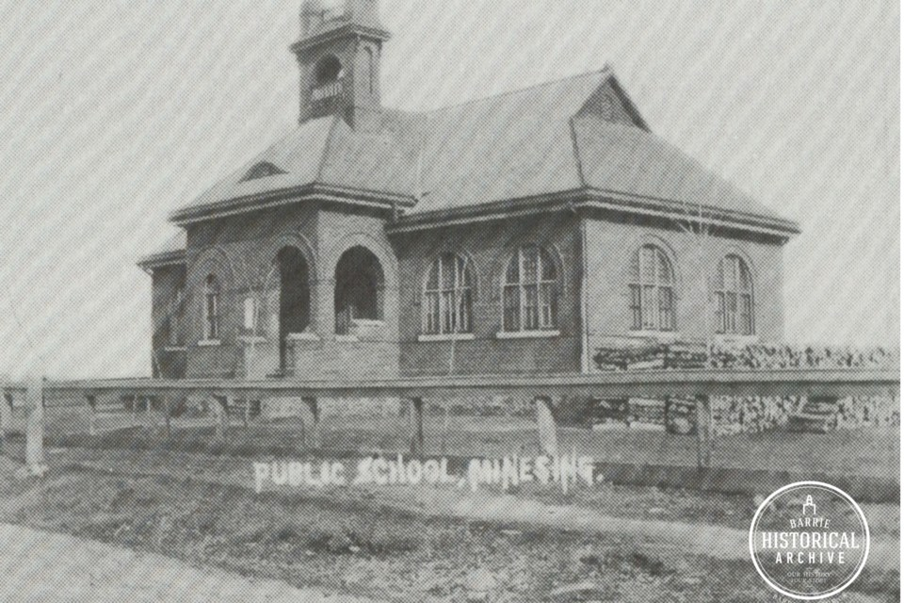

MInesing S.S. No. 9 about 1900

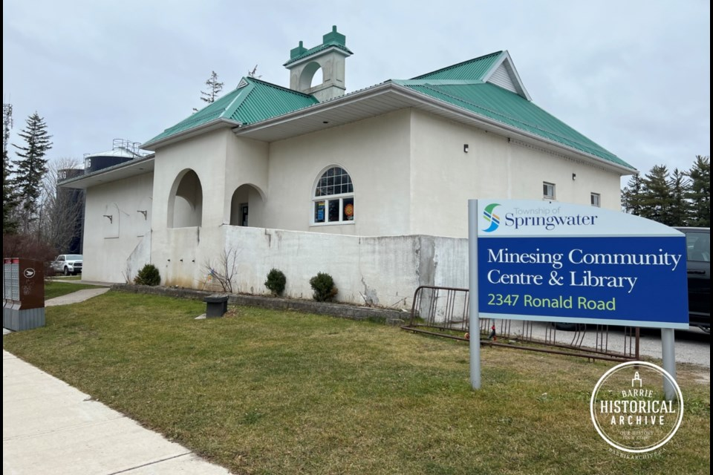

Minesing S.S. No. 9 Today

*This ongoing series from Barrie Historical Archive curator Deb Exel shows old photos from the collection and one from the present day, as well as the story behind them.*

**Minesing School**

Even in 1859, with a very modest anticipated class size of 14 students, the pioneer families of Laird’s Settlement, as Minesing was known at the time, recognized the importance of providing an education for their children.

Before the first school was built, classes were held in the home of John Laird, the first postmaster, and taught by his daughter, Isabella. Isabella would later marry Dr. Charles Bosanko and live in one of Barrie’s grandest homes, [Beverly Hall](https://www.barrietoday.com/then-and-now/then-and-now-beverly-hall-remains-a-striking-sight-6059383).

As a result of the School Act of Upper Canada, School Section No. 9 was established, and in 1860, the Vespra council elected its school trustees. The trustees borrowed $300 from the township to construct the first school house.

John Laird, once a carpenter in England before he came to Canada, constructed the frame building on a quarter-acre hillside lot on the corner of his property, located at Highway 26 and the Minesing Sideroad.

The new schoolhouse was also used as a church and Sunday School, as well as for events such as concerts and singing classes.

By 1880, the school needed to grow to accommodate the increasing number of students. A new brick schoolhouse was built on the same property, and, because the teacher at the time was a married man, a house was built for him as well.

Attendance increased to 75 children by 1894 and a partition was installed in the schoolhouse to create two rooms for the principal and the assistant.

School days continued on the hillside until 1897, when fire destroyed both the school and the teacher’s home. Only the books and equipment had been insured, in the amount of $800.

Not wasting any time, ratepayers voted on a site to rebuild the school. The new location would be situated right in the village and on a lot that was much better suited for sports, playgrounds and other events, compared to the sloping site of the former schoolhouse.

The piece of property was purchased for $99 and construction of the two-room school was underway the same year, 1897. While the building of the school was in progress, senior students had their classes in the Workman’s Hall (the Bank of Nova Scotia would one day be located there) and the junior classes were in the Grange Hall, which would later be the first site of McGuire’s Apiaries.

The architect for the new S.S. No. 9 was none other than Thomas Kennedy, of Barrie. Kennedy and his company designed numerous buildings in Barrie, Toronto and across Grey and Simcoe counties. His impressive home [Lilac Villa](https://www.barrietoday.com/then-and-now/then-and-now-a-true-heritage-treasure-lilac-villa-almost-lost-in-2017-fire-4960742), stills stands today.

The school’s centre portico entrance, embellished with an eyebrow window, led into a main hall that separated the two classrooms. The school rooms had 14-foot ceilings and enormous arched windows to let in light.

The school also had a cellar for the furnace, supplied by [Otton’s](https://www.barriearchive.ca/piece/otton-brothers-hardware-store/?utm_source=barrietoday.com&utm_campaign=barrietoday.com%3A%20outbound&utm_medium=referral" \t "_blank) in Barrie, and for storing wood. The building’s two chimneys were artfully connected to create an elegant bell tower finished with decorative cornice and ornamental cresting.

When the school opened in the fall of 1897, drinking water was brought from the village well. In the corner of the school room was a water pail residing on a backless chair, and a tin dipper hanging on a nail, if anyone got thirsty. It wasn’t until many years later that a well was drilled for the school and water piped in, supplying running water to the girls’ washroom and to two drinking fountains. Modern bathrooms would not exist until the new Minesing Central School was built.

The old Minesing school was closed in 1960.

[S.S. No. 9](https://www.barriearchive.ca/piece/minesing-s-s-no-9-school-was-designed-by-architect-thomas-kennedy/?utm_source=barrietoday.com&utm_campaign=barrietoday.com%3A%20outbound&utm_medium=referral) would open its doors again in 1964 – this time as a community centre and library. A 30-foot extension was added to the old school, making room for a kitchen and stage upstairs, and a three-lane bowling alley downstairs. More than 3,300 volunteer hours and $15,500 in donations covered the conversion expenses, with the exception of the cost of the bowling alley, which was financed.

In the process of renovating the building, the old bell, cast in Seneca Falls, N.Y. , removed from the tower and stowed when the school closed, was discovered. The bell was later restored and hung in the centre during a 1977 school reunion.

These days, old [S.S. No. 9](https://www.barriearchive.ca/piece/the-building-marker-on-the-minesing-school-designed-by-barrie-architech-thomas-kennedy/?utm_source=barrietoday.com&utm_campaign=barrietoday.com%3A%20outbound&utm_medium=referral) is an active community hub. And the bowling alley? Now four lanes and available to rent!