Orange Lawrence of Lot 1, Conc. 2 South of Dundas Street
Trafalgar Township, Halton County Ontario

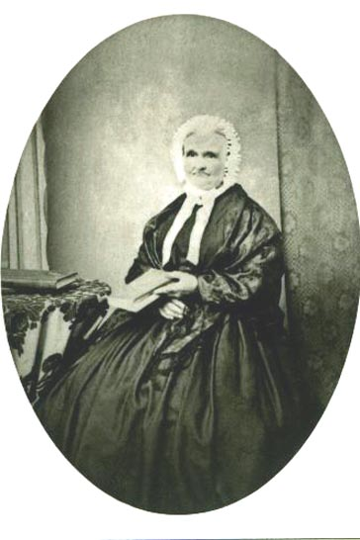
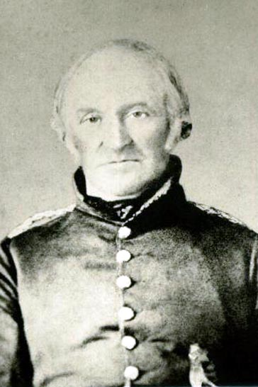

Settled at Sheridan in 1823

The farm remained in possession of the Lawrence family until 1977

Orange Lawrence Sarah House Lawrence
Generation One

1. Orange LAWRENCE, b. 23 Feb 1796 in Canaan, Litchfield CT,, (son of William Solomon LAWRENCE and Esther DUTTON) d. 15 Dec 1861 in Orangeville, Dufferin ON,^{1,} buried in Greenwood Cemetery, Orangeville ON,¹ (see note 1) occupation Farmer, Mill Operator, Storekeeper, Postmaster.
Ref 9b, 1841 Canadian Census (Canada West) Trafalgar Township, Lawrence Orange, Farmer, Proprietor Lot 1, 2nd Conc. SDS, migrated 1815 from U.S., wife and 5 children Canadian born
Ref 9c, 1851 Canadian Census Ontario (Canada West), age last birthday 56, birthplace Connecticut US, occupation gentleman, Religion Free?
Ref 9d, 1861 Canadian Census Ontario (Canada West), age next birthday 65, birthplace United States, married 1822, occupation corter?, Religion Independent
Ref, Cecil Lawrence, great grandson said: Orange bought the farm at Sheridan, Trafalgar Twp. Ont. 5 June, 1823
Ref 16c, appears to have located here (Orangeville) in 1844

Ref 16 k, The Canadian Biographical Dictionary and Portrait Gallery of Eminent And Self-Made Men, Ontario Volume, American Biographical Publishing Company 1880, page 318
Orange Lawrence a native of Connecticut, came to the Niagara District, Canada, soon after the second war between the United States and England; a few years later removed to the township of Trafalgar, County of Halton, and farmed and manufactured timber there till about 1842, when he came to the place where Orangeville now stands and purchased the site of most of the present town, together with a saw-mill and small grist-mill. At that time there were a log house and an empty shanty here. He was the first permanent settler; kept a store as well as farmed; at one time he was captain of a militia company in the rebellion of 1837; and was postmaster many years holding that office at the time of his death which occurred in 1861.

Ref 16L, 04 Dec 1833 is listed as a yeoman of Trafalgar and a bondsman for the marriage of Edward Cornwall and Ellen Adamson, pg 265

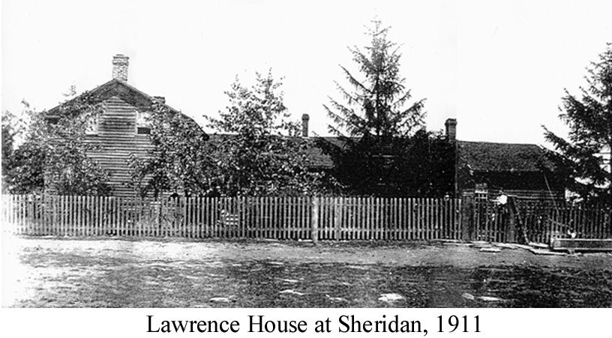

Ref 16m, More Notices from Ontario's Methodist Papers 1858-1872, Donald A. McKenzie 1993, page 164;
LAWRENCE, Orange, an old resident of Orangeville, was found dead at the end of his own house last Sun. afternoon ...... It appears there was a clothes line extending between 2 poles, and that Mr. Lawrence made a noose in the slack of the rope, which he placed around his neck, and so strangled himself ......He has left considerable property, and leaves a widow and grown family. - CJ, Dec. 27 1861, p. 2, N.I., Guelph Herald.

Ref 20a, took his own life, pg 212.

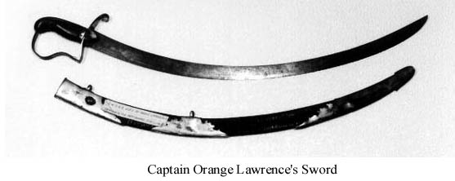

He married Sarah Angelica HOUSE, 20 Feb. 1821, b. 03 Mar 1805 in Beamsville, Lincoln ON,^{1,3} (daughter of Philip HOUSE and Mary) d. 07 Apr 1879 in Orangeville, Dufferin ON,^{1,3} buried in Greenwood Cemetery, Orangeville ON, (see note 2).
Sarah: Ref 9c, 1851 Canadian Census Ontario (Canada West), age last birthday 47, birthplace Canada, occupation lady, Religion Free
Ref 9d, 1861 Canadian Census Ontario (Canada West), age next birthday 56, birthplace not stated, married 1822, Religion W/Methodist
Ref 9e, 1871 Canadian Census, Ontario, widow, age 66, birthplace Ontario, Religion W/Methodist
Ref 13b, "Sacred to the Memory of Sarah House wife of Orange Lawrence, born at Beamsville 3 March 1805, died at Orangeville 7 April 1879 age 74 yrs" (gravestone inscription)

Ref 15, An old resident Mrs. O. Lawrence passed away this week at age 74. She came to this town (Orangeville) with her husband 9th Feb. 1848. The family at one time owned all land from Centre Road above Purple Hill to the railway crossing on Garafraxa Road. April 11, 1879

Ref 16q, granted Crown land by Order in Council, 21 Jan 1824, pg 156.

Children:
2. i. Mary b. 11 Oct 1822.
3. ii. Cyrus b. 27 Sep 1824.
4. iii. Esther Ann b. 12 Aug 1826.
5. iv. Rhoda b. 06 Feb 1829.
6. v. Ferris b. 06 Jun 1831.
7. vi. Frances b. 20 Feb 1833.
vii. Charlotte LAWRENCE, b. 20 Jul 1835 in Trafalgar Twp. Halton ON, d. 23 Jul 1835 in Trafalgar Twp. Halton ON.⁶
8. viii. Orange (Jr.) b. 04 Jul 1842.
ix. Sarah LAWRENCE, b. 13 Dec 1846 in Trafalgar Twp. Halton ON,^{6,1} d. 17 Sep 1890,^{1,3} buried 19 Sep 1890 in Greenwood Cemetery, Orangeville ON,^{1,3} never married^{6.}
Ref 9c, 1851 Canadian Census Ontario (Canada West), age last birthday 6, birthplace Trafalgar CW, occupation lady
Ref 9d, 1861 Canadian Census Ontario (Canada West), age next birthday 15, birthplace Upper Canada, Religion W/Methodist
Ref 9e, 1871 Canadian Census, Ontario, age 23, birthplace Ontario, Religion W/Methodist
Ref 9f, 1881 Canadian Census, Ontario, age 31, birthplace Ontario, Religion Methodist Canada

Ref 15, Funeral Invitation
DIED. At the residence of her brother in-law, Dr. Armstrong, Toronto, on Wednesday, Sept. 17th, 1890, SARAH LAWRENCE, Daughter of the late Orange and Sarah Lawrence. Aged 43 years. - THE FUNERAL - Will take place from the residence of Mrs. Reid, John St., at 2:30 p.m. on Friday, 19th inst., for the Town Cemetery. - Friends and acquaintances will please accept this intimation. Orangeville Sept. 18th, 1890.

Ref 15, Funeral Card:
In Loving Memory -of- SARAH LAWRENCE who departed this life WEDNESDAY, SEPTEMBER 17th, 1890 AGED 43 YEARS.

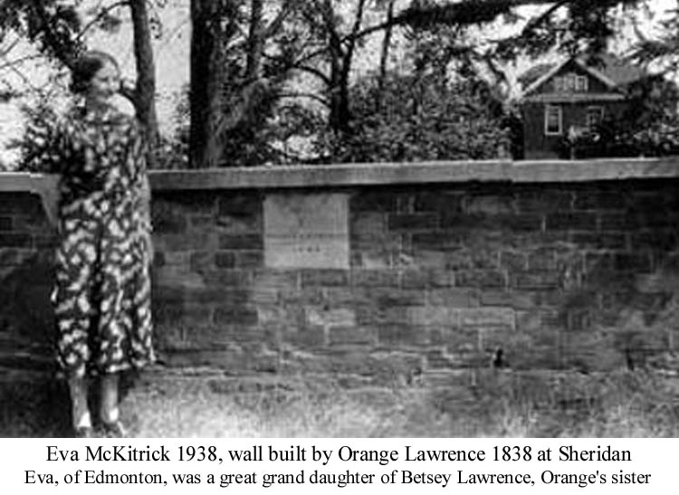

The wall built in front of the Lawrence residence at Sheridan by Orange Lawrence in 1838 was removed by construction crews building the South Service Road. According to the Lawrence family the concrete plaque was to be preserved, but one morning upon hearing the construction crew at work they rushed out and found that the plaque had been destroyed.

As seen in the background a modern brick house was built in 1913 replacing the original frame house.

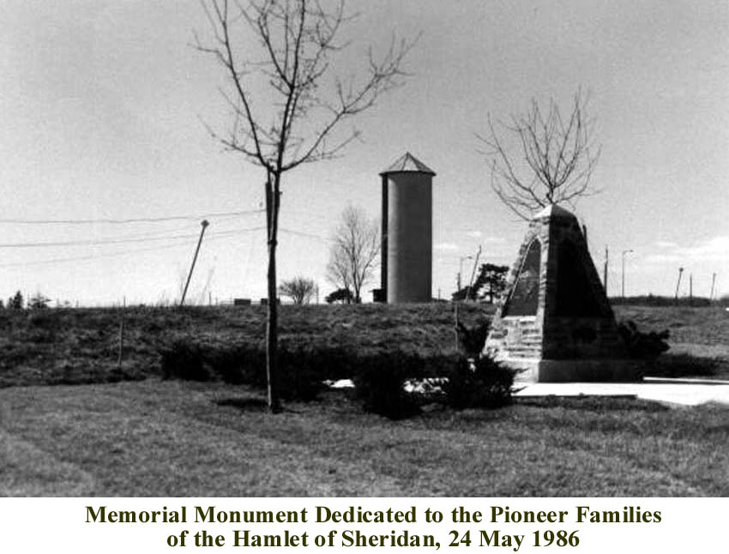

Generation Two

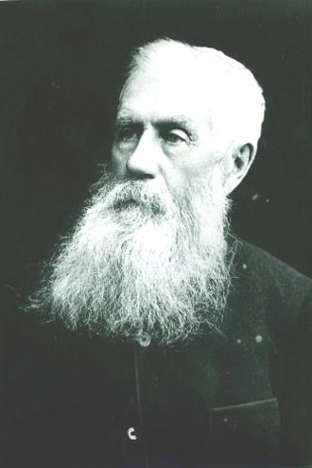
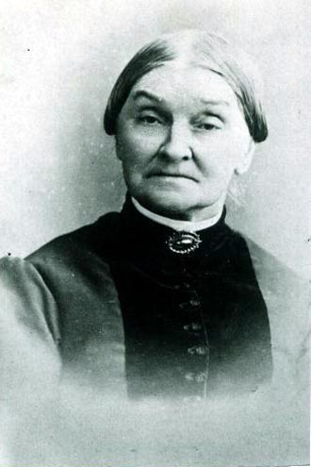
Mary Lawrence, eldest daughter of Orange Lawrence, married Thomas Jull.

They lived at Lot 5, Conc. 2, south part, South of Dundas Street, Trafalgar Township, Halton County, Ontario

( 9th line south of Upper Middle Road)

Mary Lawrence Thomas Jull

2. Mary LAWRENCE, b. 11 Oct 1822 in Trafalgar Twp. Halton ON,^{,1} d. 29 Mar 1904 in Toronto, York ON, buried in Greenwood Cemetery, Orangeville ON,¹ (see note 3).
Ref 9d, 1861 Canadian Census Ontario (Canada West), age next birthday 38, birthplace Upper Canada, married 1838, Religion W/Methodist
Ref 9e, 1871 Canadian Census, Ontario, age 51, birthplace Ontario, Religion W/Methodist
Ref 9f, 1881 Canadian Census, Ontario, married, age 58, birthplace Ontario, Religion Methodist Canada
Ref 9g, 1891 Canadian Census, Ontario, age 66, birthplace Ontario, Religion Methodist
Ref 9h, 1901 Canadian Census, Ontario, widow, age 78, birthplace Ontario, birth date 11 Oct 1823, occupation retired, Religion Methodist

Ref 15a, The Orangeville Banner, April 1904, Obituary: Mrs. Thos. Jull
On Thursday March 29th the death of Mrs. Thos. Jull, an old and highly respected resident of this town, took place at the home of her son, Mr. Orange Jull, 97 MacDonell Ave. Parkdale. Her demise occurred at the ripe age of 81 years and 6 months. The deceased lady was the oldest daughter of Orange and Sarah Lawrence, the former of whom was the founder of Orangeville. She was born near Oakville on October 11th, 1822. She came to Orangeville with her husband in the autumn of 1857. The latter was for many years one of Orangeville's most active and public spirited citizens. He it was who built the stone flour mill at present operated by Summerfeldt Bros. He also erected the old Millet Foundry where the Electric Light power house now stands. On the incorporation of Orangeville as a town he became it's first reeve. After the death of her husband in Nov. 19th, 1896, Mrs. Jull continued to reside in the house which they had built on the corner of John and Little York Sts. and which was the first brick residence in Orangeville. In 1901, however she sold her home to Mr. Geo. McIntyre and after a continuous residence of 44 years in the town, moved to Toronto where she has since lived with her son. A faithful and loyal member and an earnest worker in the Methodist church from her childhood, her home was always open to church workers and especially to Methodist ministers, who showed their esteem and gratitude by six of their number attending the service at her late home in Parkdale. Of a family of nine children, two sons, Bennett and Orange, of Toronto survive. She leaves nine living grandchildren, two great grandchildren, two adopted daughters, Mrs. Burgher, of Toronto and Mrs. (Dr.) Dorland of Oakville, two brothers, Ferris of Sheridan, and Orange of Orangeville, and two sisters, Mrs. Reid and Mrs. (Dr.) Armstrong of Toronto. At the request of her old-time friends her remains which were brought to Orangeville for interment, were conveyed to the home of her niece, Mrs. Geo. Beswick, West Broadway, where a short service was held by Rev. Mr. Bartley on Friday afternoon and her sorrowing friends were allowed the opportunity of looking for the last time upon the face of one of the pioneers of Methodism in Orangeville. The interment took place in Greenwood cemetery.

She married Thomas Charles JULL, 01 Oct 1839,^{6,} b. 17 Feb 1817 in Kent, England,^{1,} (son of Henry JULL and Harriet (Martha) HARRIS) d. 19 Nov 1896 in Orangeville, Dufferin ON,¹ buried in Greenwood Cemetery, Orangeville ON,¹ occupation Miller / Councilman / Justice of the Peace.^{3,10}
Thomas: Ref 9d, 1861 Canadian Census Ontario (Canada West), age next birthday 44, birthplace England, married 1838, occupation miller, Religion W/Methodist
Ref 9e, 1871 Canadian Census, Ontario, age 57, birthplace England, occupation millright, Religion W/Methodist
Ref 9f, 1881 Canadian Census, Ontario, married, age 64, birthplace England, occupation gentleman, Religion Methodist Canada
Ref 9g, 1891 Canadian Census, Ontario, age 74, birthplace England, occupation retired farmer, Religion Methodist

Ref 10k, From Brock to Currie; The Military Development and Exploits of Canadians in General and the Men of Peel in Particular. 1791 - 1905 - The Perkins Bull Foundation - George J. Mcleod Ltd. Toronto, 1935, pg 673
Thos. Jull, Lt. Orangeville Inf. Coy., 19th Dec. 1862; served in Fenian Raid, 1866; resigned, 22nd June, 1866

Ref 13b, "Thos. Jull born Kent England Feb. 17 1817 - died in Orangeville Nov. 19 1896" (gravestone)

Ref 15, 50th wedding anniversary 01 Oct 1895 (?), died aged 79 years, 6 months, he was born in Kent County England in 1815, he came to Canada in 1835 settling in Trafalgar Twp, in 1856 he came to Orangeville, Mr. Jull became the first Reeve of Orangeville on it's incorporation.

Ref 15, Dufferin Advertiser, November 26, 1896, A GOOD MAN IS GONE: The Career of an Old Resident of Orangeville.
LIVED HERE FORTY YEARS: Review of the life of Thomas Jull.
By the death of Mr. Thomas Jull last week Orangeville lost one of its oldest and most esteemed citizens. Mr. Jull had been ailing for some time and his increasing weakness terminated in paralysis a few weeks ago. With paralysis came unconsciousness, which continued until the vital spark fled at an early hour on Thursday morning. It is just a year ago since the Advertiser printed a brief sketch of Mr. Jull's career, which we cannot do better than republish here;

A TRIBUTE OF A YEAR AGO: The Career of an Old Resident of Orangeville. Reeve For Several Years, Also Warden of Wellington - A Worthy Citizen.
"Thirty-eight years ago Mr. Thomas Jull built the brick house in which he still lives on Little York street. It was the second house built of brick in Orangeville. Mr. Jull had moved his family here the year before, in 1856, from Trafalgar township near Oakville, where he had spent twenty-one years of his life. He will be 79 years of age next February. Born in England, within six miles of historic Canterbury, he came to Canada in 1835, and for nearly forty years past, Orangeville has been his home.
Orangeville is yet a young town. The population was limited to a few dozen souls two score years ago. Mr. Jull was one day lost in a swamp where his house now stands - and that was less than forty years ago. To-day we have a prosperous town of nearly 4000, with all the modern conveniences of which larger and older towns can boast. We are progressing.
Mr. Jull was a miller. He built the first stone flour mill the town possessed, on the site of the present mill on Mill street. Later he confined his attention to a sawmill which he built down in the east ward and which went up in smoke one wild night in the turbulent Scott Act days. For Mr. Jull was a fearless magistrate then and being a fearless temperance man, it was found necessary to apply the torch of intimidation. Prior to this he had filled, with honor to himself and profit to the community, the responsible position of reeve of the village and warden of the county of which it then formed a part. He was president of the Reform Association of Dufferin for many years and at the first Provincial election that followed the formation of the county in 1882, contested the constituency in the Liberal interests. He was unsuccessful of course as most Reformers are in this hive of Toryism, but he emerged from the contest with a creditable vote and a clean record.
Mr. Jull's memory suffered in recent illness and his recollection of past events is not as clear as it was a few months ago. He remembers the time, however when Orange Lawrence abandoned the milling business and went hotel keeping and was afterwards succeeded as "mine host" of the village tavern by Robt. Galbraith, father of Frank and George.
The partner of Mr. Jull's joys and sorrows for half a century is still spared to bless his declining years. Mrs. Jull is a lady of many estimable qualities. One daughter, Mrs. John Lindsey of Melancthon and two sons, Bennett of Ridgetown and Orange of Orangeville, are living fruits of a happy union. Needless to add, Mr. Jull, sr., has been an indulgent grandfather for many years past." He still enjoys fairly good health and the hopes of his many friends is that he may live long to enjoy the peace that has characterized his declining years.

THE LAST OF A GOOD MAN: Such was the life of Thomas Jull. In the year that has elapsed since the publication of the above Mr. Jull's daughter, Mrs. Lindsey of Melancthon, has passed away, and now Mr. Jull has himself joined the silent and ever increasing majority. The large attendance of sympathetic citizens at the funeral on Saturday afternoon evidenced the respect and esteem in which the deceased was held. At 2 o'clock the remains were conveyed from the residence on York street to the Methodist church, where the pulpit, organ and gallery were draped in mournful black. During the brief memorial service which followed, the pastor, Rev. Mr. Langford, Rev. Mr. Goodman and Sheriff Bowles of Orangeville, Rev. Mr. Redditt of Brampton spoke in the highest terms of Mr. Jull's Christian-like character. The interment followed in Greenwood cemetery.

THE YOUNG LIBERAL"S TRIBUTE: At the meeting of the Young Liberal Club on Friday night President Wallace referred to the death of Mr. Jull and Messrs Dodds and McKay, also gave expression of the club's sincere regrets. A resolution of condolence with the bereaved family was then adopted.

Ref 16 k, The Canadian Biographical Dictionary and Portrait Gallery of Eminent And Self-Made Men, Ontario Volume, American Biographical Publishing Company 1880, page 317, 318
THOMAS JULL - ORANGEVILLE: The subject of this brief notice is a descendant of a family of English agriculturist, and dates his birth in the County of Kent, February 17, 1817. His parents were Henry and Harriet (Harris) Jull. The name is not very common either in England or Canada; there are few families of that name in this Province.

Thomas received an ordinary English education; did some farming with his father in boyhood; learned the trade of a millwright, and then abandoned it; in the autumn of 1835, left his fatherland; came to Trafalgar, in the County of Halton and farmed and ran a saw mill for twenty-one years, having a liberal experience of frontier life and hard work. When he first settled in that county much of the soil was covered with standing timber, and he furnished the material for many a pioneer's humble frame house.

In the spring of 1856, Mr. Jull settled in Orangeville, then a small hamlet; built a grist mill that year; bought a saw mill the next and is still engaged in the manufacturing of lumber, agriculture, and other pursuits. The grist mill he sold in 1876, after running it for twenty years.

Mr. Jull has been a Justice of the Peace more than thirty years; was a councilman at one time in the township of Garafraxa (which includes part of the town of Orangeville), and was the first reeve of Orangeville serving in that position for several terms. He has long been chairman of the local School Board, and is also one of the License Commissioners for the county. Mr. Jull was President of the Tramway Company, which finally culminated in getting the Toronto, Grey and Bruce Railway, which came to Orangeville in 1871. The Credit Valley Railroad reached this town in December 1879. He abounds in public spirit and no man has done more towards furthering the interest of the place.

Until the County of Dufferin was formed, Garafraxa was in the County of Wellington; and Mr. Jull was at one time President of the Reform Association for the Centre Riding of that County.

He is a communicant in the Methodist church of Canada; for a long period has been an official member of that body, and is a man in whose integrity and general uprightness of life the most implicit confidence is placed. He is a kind neighbor, and a true friend to the needy and industrious.

In October, 1839, he married Miss Mary Lawrence, daughter of Orange Lawrence, founder of Orangeville, and after whom the place was named; and of nine children resulting from this union, only four are living. All are married but Cyrus, who is at home and in delicate health. Sarah, the only daughter living, is the wife of John Lindsey of Shelburne, County of Dufferin; Bennett is a merchant at Ridgetown, Kent County, and Orange resides in Orangeville.

Ref 15, Mr. Thomas Jull, one of Orangeville's oldest and most respected citizens is lying at the point of death at his residence on York street. He has been failing rapidly during the past few months and his increasing weakness resulted in a stroke of paralysis last week, which it is feared by his many friends will prove fatal.

Ref 15, DIED: JULL - In Orangeville, on the 19th inst., Thos. Jull, aged 79 years and 6 months.

Ref 15, Funeral Card - DIED - In Orangeville, on Thursday, November 19th, 1896, THOMAS JULL, Aged 79 Years and 9 Months - THE FUNERAL, Will leave his late residence, York Street, at 2 p.m. on Saturday, 21st Inst., and proceed to the Methodist Church for Devine Service, thence to Greenwood Cemetery for Interment.

Children:
i. Sarah JULL, b. 05 Jan 1842 in Trafalgar Twp. Halton ON, d. 07 Jun 1896,⁵ buried in Greenwood Cemetery, Orangeville ON.⁵
Ref 9d, 1861 Canadian Census Ontario (Canada West), age next birthday 19, birthplace Upper Canada, Religion W/Methodist
Ref 9f, 1881 Canadian Census, Ontario, married, age 38, birthplace Ontario, Religion Methodist Canada.

She married John LINDSEY, 1862,⁶ b. 1836 in Ontario, Canada,^{6,} d. 27 Mar 1913,⁵ buried in Greenwood Cemetery, Orangeville ON,⁵ occupation Grain Merchant.¹²
John: Ref 9f, 1881 Canadian Census, Ontario, married, age 43, birthplace Ontario, occupation grain merchant, Religion Methodist Canada
Ref 13b, died 27 Mar 1913, age 76 yrs, 8 mos. (tombstone inscription).

ii. Bennett H. JULL, b. 21 Feb 1844 in Trafalgar Twp. Halton ON,^{11,} d. 21 Dec 1912 in Toronto, York ON,^{13,3} buried in St. Jude's Cemetery, Oakville ON,¹³ occupation Merchant.,,
Ref 9d, 1861 Canadian Census Ontario (Canada West), age next birthday 17, birthplace Upper Canada, Religion W/Methodist
Ref 9e, 1871 Canadian Census, Ontario, age 26, birthplace Ontario, occupation merchant, Religion W/Methodist
Ref 9f, 1881 Canadian Census, Ontario, married, age 36, birthplace Ontario, occupation merchant, Religion C. Methodist
Ref 9r, married in St. Jude's Anglican Church, Oakville ON

Ref 15, in 1867 he engaged in a mercantile business at Oakville with his father-in-law W.E. Hagaman, in 1877 they removed to Ridgetown where they opened a large general store, in 1899 they disposed of the business, he died at his home in Toronto, ON

Ref 15f, Canadian Champion, Milton Ont., April 18, 1872, MARRIED:
Jull - Hagaman. On the 4th instant at St. Jude's church by the Rev. J.B. Worrell M.A., Bennett H. Jull, Merchant, eldest son of Thomas Jull, Esq., of Orangeville and Mary Ellena Louise, only daughter of W.E. Hagaman, Merchant, all of Oakville. No Cards.

Ref 16j, An Account of Three Families - The Hagamans - The Julls - The Fultons, by Edgar Fulton Jull, October 1997, page 5, 6, 7, 14, 15
Bennett Jull (born 1844) was a son of Thomas Jull of Orangeville. After finishing school, he accepted a clerkship in a general store in Orangeville. Later he moved to a similar clerkship in Tullamore, then moved to Oakville, where he obtained employment in the Gage and Hagaman store (1867).

Working as a clerk in the store, he of course met the boss's daughter, Mary Hagaman. We do not know the sequence of events, but we do know that on April 4, 1872, they were married. The name of the firm was changed to Hagaman and Jull.
Two children were born, the first, a girl, Ellena in 1873; the second, Thomas Worthington, in 1875. To the everlasting sorrow of their parents, Ellena died at the age of four - - the cause, diptheria. A single small column is in the Oakville cemetery plot, inscribed: "our darling".

Business continued to be good for some time. However, by the mid - 1870's several factors changed the picture: The Canadian West was opening up, and grain coming from the west resulted in vanishing profits for local grain dealers. As well, the coming of the railway drew business to more central sites. The town of Oakville was in a depression with population shrinking. Hagaman and Jull reduced their large store by half, leasing one half to their former head tailor in the custom-made men's clothing department. They also considered the idea of relocating to another town.

The location they decided on was Ridgetown, which was in the centre of a good agricultural region near Chatham. Some time between April, 1879 and May 1880, the business was moved to this new location (exact date is uncertain). The general store which they opened in Ridgetown became active and successful. The firm of Hagaman and Jull carried on business as general dry goods merchants in Ridgetown until the death of the senior partner, Worthington E. Hagaman, on August 31, 1896. While writing a business letter in his office, he suffered a stroke.

Following the sale of the Hagaman and Jull business to Northway and Anderson, Bennett Jull and his wife Mary decided to take up residence in Toronto (their son Thomas W. Jull was already living and working in Toronto). On Aug. 26, 1901, Mary E.L. Jull entered into an Agreement of Sale whereby their home in Ridgetown was sold to Mary Jull's sister-in-law, Mary Hagaman (wife of her brother Gage Hagaman). The Agreement of Sale was very detailed. It also included a burial lot in Greenwood Cemetery in Orangeville. Bennett Jull, though retired, still kept accounts of transactions made by himself and his wife. Some of these transactions were written on the hotel stationery of the Marlborough Hotel, at 208, 210, 212, 214, Jarvis Street in Toronto. From this we can assume that they had taken residence at this hotel.

In 1905, they decided to take a trip to California. After returning to Toronto, they purchased a house at 46 Gerard Street East (near Church Street). Only seven years later on December 22, 1912, Bennett Jull died. It may be that he died in Church. There is a bill from J.A. Humphfrey and Son, Funeral Directors: To ambulance service from Metropolitan Church to residence $2.00. Bennett Jull's will appointed Mary Ellana Louisa Jull, Widow and Thomas W. Jull (his son) as Executrix and Executor. He made two bequests of $5000.00 each to his son, and the rest and residue: to my wife Mary Ellana Louisa Jull for her own use and benefit for and during the term of her natural life if she shall so long remain my widow and upon her death or sooner marriage I will and bequeath the same to my son Thomas W. Jull for his own use and benefit absolutely.

He married Mary Ellena Louisa HAGAMAN, 04 Apr 1872 in Oakville, Halton ON, b. 15 Jun 1851 in United States,^{17,13} (daughter of Worthington Ely HAGAMAN and Susan HAGAMAN) d. 11 Feb 1935 in Ridgetown, Kent ON,^{13,3} buried in St. Jude's Cemetery, Oakville ON.¹³
Mary: Ref 9f, 1881 Canadian Census, Ontario, married, age 31, birthplace U.S.A., Religion Church of England
Ref 16j, born on the Hagaman farm in 1851, the same year they decided to emigrate to Canada.

iii. Orange JULL, b. 24 Sep 1845 in Trafalgar Twp. Halton ON,^{,9} d. 15 Mar 1920 in Toronto, York ON, buried in Prospect Cemetery, Toronto ON,¹⁹ occupation Saw Mill owner; inventor rotary snowplow.^{,19,}
Ref 9d, 1861 Canadian Census Ontario (Canada West), age next birthday 16, birthplace Upper Canada, Religion W/Methodist
Ref 9e, 1871 Canadian Census, Ontario, age 25, birthplace Ontario, occupation not given, Religion W/Methodist, married Oct
Ref 9f, 1881 Canadian Census, Ontario, married, age 35, birthplace Ontario, occupation saw mill owner, Religion Methodist Canada
Ref 9g, 1891 Canadian Census, Ontario, age 45, birthplace Ontario, occupation inventor, Religion Methodist
Ref 15, member 1st Battalion Militia, Orangeville 1865

Ref 15h, The Orangeville Sun, 13 Oct 1870: MARRIED
JULL - McKEOWN: On the 13th inst. at the residence of the Bride's parents, by the Rev. T.S. Howard, Orange Jull, Esq., to Maggie McKeown, second daughter of R. McKeown, Esq., all of Orangeville

Ref 15h, The Orangeville Sun, 14 Oct 1897, GONE to THEIR NEW HOME:
Mr. Orange Jull and family left town yesterday for their new home in Toronto. Mr. Jull has resided in Orangeville continuously since the year 1857, when his father the late Thomas Jull, settled here, and was one of the town's first improving citizens. Some years ago Mr. Jull sold his flour and saw mills and since then has been transacting just enough business to keep him from growing rusty. By the removal of his family the Methodist church sustains a heavy loss, as Mrs. Jull and family were ever foremost in all church work and were deservedly popular and all will sincerely regret their departure. The SUN wishes them every happiness in their new home.

Ref 15i, The Toronto Daily Star, March 16, 1920: FUNERAL of ORANGE JULL
The funeral of Orange Jull, of 20 Thorold avenue, who was born in Trafalgar, Ont., 75 years ago, and lived many years in Orangeville, took place this afternoon to Prospect Cemetery. In the absence of the pastor, Rev. Dr. Cleaver, the service was in charge of Rev. W.R. Barker, a former pastor, assisted by Rev. Dr. W.B. Creighton, editor of the Christian Guardian, and Rev. George M. Brown, also a former pastor. Many other ministers and laymen of the church were present. The pall-bearers were Walker E. Stewart, Clarence James, Arthur Moysey, all sons-in law of the deceased, together with Worthington Jull, F.H. Clarke and Walker Kearns, nephews.

He is survived by his wife and three daughters, Mrs. Walker E. Stewart, Mrs. Clarence James and Mrs. Arthur Moysey. The late Mr. Jull made the model for the first rotary snow plow, which was built from this at the Polson Iron Works. He invented the Jull-Centrifugal now in use in the United States and Canada and improvements on other mechanical contrivances.

He married Margaret (Maggie) McKEOWN, 13 Oct 1870 in Orangeville, Dufferin ON, b. 1848 in Ontario, Canada, (daughter of Robert McKEOWN and Margaret GRAHAM) d. 14 Feb 1936,³ buried in Prospect Cemetery, Toronto ON.³
Margaret: Ref 9e, 1871 Canadian Census, Ontario, age 22, birthplace Ontario, Religion W/Methodist
Ref 9f, 1881 Canadian Census, Ontario, married, age 32, birthplace Ontario, Religion Methodist Canada
Ref 9g, 1891 Canadian Census, Ontario, age 42, birthplace Ontario, Religion Methodist
Ref 15, died at the home of her daughter Mrs. W. Stewart, age 87.

iv. Cyrus JULL, b. 24 Sep 1847 in Trafalgar Twp. Halton ON, d. 08 Apr 1880 in Orangeville, Dufferin ON,^{1,} buried in Greenwood Cemetery, Orangeville ON.¹
Ref 9d, 1861 Canadian Census Ontario (Canada West), age next birthday 14, birthplace Upper Canada, Religion W/Methodist
Ref 9e, 1871 Canadian Census, Ontario, age 23, birthplace Ontario, occupation law student, Religion W/Methodist

Ref 15f, Canadian Champion, Milton Ont., April 22, 1880, OAKVILLE NEWS:
Cyrus Jull, brother of Bennett Jull, late of this town, died of consumption at Orangeville last week.

Ref 15, OBITUARY:
The death of the late Cyrus Jull, of Orangeville took place on the 8th inst., and was noted that day just as we were going to press. He was a young man of irreproachable character, of great intelligence, and one possessed of the strongest sympathy and affection. His peculiarities, which were in some respects strongly marked, all leaned to the side of virtue and broad common sense. He was much attached to the church of his adoption, to his home, and his many relatives and friends. The highest respect in which the deceased and his family are held was evidenced by the numbers which attended the funeral on Sunday afternoon, and crowded the O. M. church in the evening to listen to the funeral sermon by Rev. Mr. Hunt, improving the death of this church member, Sabbath school teacher, and warm hearted friend. The lines which are eminently characteristic of the deceased, were composed by Mr. J.W. Shaw, of this town, and addressed to the sorrowing parents.

AN ACROSTIC
C ontentment M'ark'd his brief career,
Y outh's follies were deplor'd;
R eading and prayer he deeply priz'd
U pward his thoughts still soar'd.
S erene and calm life's current ran,

J ust slowly ebb'd away,
U nruffl'd by the storms of life,
L eaving a world of sin and strife
L ives now in endless day!

Ref 15, CYRUS JULL:
The subject of this notice was born near the village of Oakville, where his father was well known as an official member of the Methodist Church. Over twenty years ago the family moved to Orangeville. Cyrus was the youngest son. As he grew up to manhood, the fear of God was before his eyes and after hesitation and deep conviction he became very decided, and sought and found salvation. For several years he was a consistent member of the Church, and in all matters pertaining thereto took a deep interest. In nothing was the interest more evident than in the young men's Bible class, connected with the Sabbath school, of which he was a faithful member. Failing health compelled him about four years ago, to give up his law studies, which he had entered upon some time before, and prosecuted with much diligence. To him it was a great trial when obliged during the winter to desist attending the sanctuary, and his favorite Bible class. He was faithful to the last. His pastor called to see him a couple of hours before his death, and remained until the closing scene. He expressed a fervid assurance that God would give him grace to triumph. An aged workman of his father's came in, and on taking leave said, "I will see you again." "Yes," said Cyrus, "I hope so, up yonder," pointing heavenward; "but be sure you don't put off preparation to a death-bed." The end rapidly drew nigh, and he died leaning his head on the shoulder of his father, on the 8th day of April, aged thirty-two years. J. Hunt.
v. Samantha JULL, b. 1849, d. 19 Dec 1849,²⁶ buried in Spring Creek Cemetery, Clarkson ON.²⁶
Ref 13d, died aged 10 days.
vi. Charles JULL, b. 1851,²⁶ d. 02 Nov 1851,²⁶ buried in Spring Creek Cemetery, Clarkson ON.²⁶
Ref 13d, died aged 11 days.
vii. Wesley C. JULL, b. 1857,²⁶ d. 25 Apr 1857,²⁶ buried in Spring Creek Cemetery, Clarkson ON.²⁶
Ref 13d, died aged 18 days.
viii. Frances Hannah (SPECK) JULL, b. 06 Feb. 1861 in Ontario, Canada, d. 25 Dec 1925 in Oakville, Halton ON, buried in Palermo Cemetery, Oakville ON.²⁸
Note: Her original name before adoption was Hannah Speck, WDK
Ref 9e, 1871 Canadian Census, Ontario, name Hannah Speck, age 16, birthplace Ontario, occupation servant, Religion W/Methodist
Ref 9d, 1861 Canadian Census Ontario (Canada West), age next birthday 7, birthplace Upper Canada, Religion W/Methodist
Ref 9f, 1881 Canadian Census, Ontario, age 25, birthplace Ontario, occupation servant, Religion Methodist Canada
Ref 9g, 1891 Canadian Census, Ontario, daughter, age 27, birthplace Ontario, Religion Methodist
Ref 9h, 1901 Canadian Census, Ontario, age 40, birthplace Ontario, birth date 6 Feb 1861, Religion Methodist

Ref 15a, The Orangeville Banner, Dec. 31, 1925, Obituary: MRS. C. B. DORLAND
Following a brief illness, Frances Hannah Jull, relict of the late Dr. Charles Dorland, formerly of Orangeville, passed quietly away at her home in Oakville on Christmas evening. The end came quite suddenly, as almost up to the time of her death Mrs. Dorland had enjoyed excellent heath and had been able to attend church services the Sunday before. Mrs. Dorland was born in Orangeville and had lived in Oakville 27 years. She was predeceased by her husband five years ago. She was a member of St. John's United Church and had always taken an active interest and part in its different organizations. Deceased was in her sixty-seventh year. The funeral was held Sunday from her home on Dundas street, to Palermo cemetery.

She married Charles Baldwin (Dr.) DORLAND, May 1894,³ b. 09 Sep 1857 in Palermo, Trafalgar Twp. Halton ON,^{28,3} (son of Erastus DORLAND) d. 19 Feb 1912,²⁸ buried in Palermo Cemetery, Oakville ON,^{28,3} occupation Dentist.^{,3}
Charles: Ref 9f, 1881 Canadian Census, Ontario, age 25, birthplace Ontario, occupation dentist, Religion Wesleyan Methodist, residing in the hotel kept by John Paisley

Ref 15, born in 1855, - historic plaque: "c. 1893 Charles Baldwin Dorland Dentist", Town of Orangeville, 29 Wellington St.

Ref 15h, The Orangeville Sun, 09 Oct 1879, advertisement, DENTISTRY:
C.B. Dorland L.D.S., Dentist, late of Oakville. Office - Over J. Lindsey's Store, Broadway, Orangeville. References in Oakville: Dr. Lusk, Dr. Buck, Dr. McCrimmon, Dr. Clarke, W.H. Young, merchant, M.S. McCraney, merchant, W. McCraney, lumber dealer.

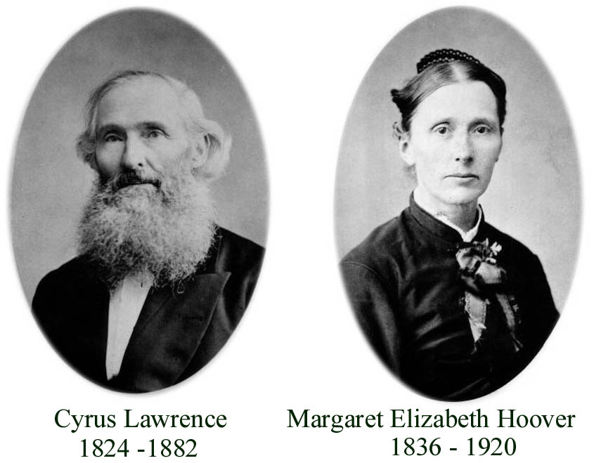

Cyrus Lawrence farmed Lot 5 Conc. 1 South of Dundas Street,
Trafalgar Township, Halton County, Ontario

3. Cyrus LAWRENCE, b. 27 Sep 1824 in Trafalgar Twp. Halton ON,^{6,,} d. 09 Jan 1882 in Trafalgar Twp. Halton ON,^{,31} buried in Cosmopolitan Cemetery, Mississauga ON,³¹ (see note 4) occupation Farmer.,
Ref 9c, 1851 Canadian Census Ontario (Canada West), age next birthday 25, born Canada, occupation farmer, Religion W/Methodist
Ref 9d, 1861 Canadian Census Ontario (Canada West), age next birthday 37, birthplace Upper Canada, occupation farmer, Religion W.
Ref 9e, 1871 Canadian Census, Ontario, age 46, birthplace Ontario, occupation farmer, Religion W/Methodist, origin Dutch

Ref 12L, Will dated Trafalgar 05 Feb 1873, Codicil 08 Jan 1882, the day before his death, Probate 11 Dec 1889
I Cyrus Lawrence of the Township of Trafalgar, being as usual sound in body and mind, thanks be unto god; but calling unto mind the mortality of my body, knowing that it is appointed unto all men once to die, to make and ordain this my last will and testament; that is to say principally and first of all I give and recommend my soul into the hands of almighty god that gave it, and my body I recommend to the earth, to be buried in decent Christian burial at the direction of my executors; nothing moulting but at the general resurrection. I shall receive the same again by the almighty power of god. And as touching such worldly estate wherewith it hath pleased god to help me with; I give, devise and dispose of the same in the following manner and form:
First Debt any funeral expense be paid. I give Margaret Elizabeth my dearly beloved Wife all my landed property to have and to hold during her widowhood Whist is so long as she remains my widow. If my wife Elizabeth marries I then give her fifty dollars each and every year during her life to be raised and __?? out of the rent of the estate.
I give to Hoover Henry Lawrence and to John Harvey Lawrence and to Herman Morley Lawrence my beloved sons the remnant of the rent of the estate to be divided equally among them. If there being a son or sons born to me I give them an equal share, that is I wish the boys to share alike. I give to Mary Helena Lawrence my beloved Daughter the sum of four hundred dollars to be fixed when she arrives at the age of Eighteen years. This to be raised out of the farm work and loose property.
At the death my wife Elizabeth I will that the Estate be sold and the money equally divided among the boys, that is between Hoover Henry Lawrence and John Harvey Lawrence and Herman Morley Lawrence and any other sons that may be born to me. I hereby appoint my beloved wife Margaret Elizabeth Lawrence, Hoover Henry Lawrence and John Harvey Lawrence, my executors. Dated this fifth day of Feb 1873. CYRUS LAWRENCE
Signed & Sealed in the Presence of Ferris Lawrence, Edward Savage.

Trafalgar 8th January 1882
I give to Mary Helena Lawrence my beloved Daughter the sum of five hundred dollars in place of the four hundred mentioned in the body of the will. This to be raised out of the farm at the time of sale.
CYRUS LAWRENCE

Ref 15, CYRUS LAWRENCE, of Dundas Street, township of Trafalgar, departed this life, January 9th, 1882, aged fifty-seven years; he was the eldest son of the late Orange Lawrence - from whom the town of Orangeville derived it's name - was born on the Midddle Road, near where his family resides, and where he has spent the greatest part of his life; was led to seek Christ about twenty-six years ago, under the influence of services held at Stafford's School house by the Rev. B. Nankaville, from which time he has preserved the most unsullied character, being a man of very conscientious principles, always considering first what his duty as a Christian was and then acting promptly in accordance with such consideration, giving to the support of the various institutions of the church, as his means would permit. He leaves a wife, three sons, and two daughters to morn his loss, all of whom are members of the Church, who received the comforting assurance at his last moments that although suffering much, he still felt that Christ was ever precious. His remains were interred in the Union Methodist Burying grounds at Springfield, and the services improved upon by the Rev. G. Brown of Cooksville; from that beautiful passage of scripture found in John iv. 2: "In my Father's house are many mansions; if it were not so I would have told you. I go to prepare a place for you." F.L.

He married (1) Sarah Ann KING, 09 June 1852,⁶ b. 1829 in Ontario, Canada,^{33,31} (daughter of John KING and Hanna H.) d. 03 Jun 1854,³¹ buried in St. Peter's Anglican Cemetery, Erindale ON,³¹ (see note 5).
Sarah: Ref 9c, 1851 Canadian Census Ontario (Canada West), age next birthday 21, born Canada
Ref 9e, 1871 Canadian Census, Ontario, age 18, birthplace Ontario
Ref 13g, died 03 Jun 1854 age 24 years, 9 mos. 23 days (tombstone inscription)
Ref 24e, born 11 Aug 1829.

Children:
i. Hannah Ann (Annie) LAWRENCE, b. 31 Mar 1853 in Ontario, Canada.
Ref 9d, 1861 Canadian Census Ontario (Canada West), age next birthday 8, birthplace Upper Canada, Religion W.
Ref 9e, 1871 Canadian Census, Ontario, age 18, birthplace Ontario
Ref 9f, 1881 Canadian Census, Ontario, married, age 24, birthplace Ontario, Ethnic Origin American, Religion Presbyterian.

She married Jeremiah R. DODDS, 08 Oct 1879 in Brampton, Peel ON, b. abt 1853 in Ontario, Canada, (son of George DODDS and Catherine) occupation Duggist.³⁶
Jeremiah: Ref 9f, 1881 Canadian Census, Ontario, married, age 28, birthplace Ontario, occupation Druggist, Religion Presbyterian.

He married (2) Margaret Elizabeth (Lizzie) HOOVER, 06 Mar 1855,³⁰ b. 17 May 1836 in Picton, Prince Edward ON,^{,30} (daughter of Henry H. (Jr.) HOOVER and Mary McLAUGHLIN) d. 06 Feb 1920 in Partridge Hill, Strathcona AB.^{30,}
Margaret: Ref 9d, 1861 Canadian Census Ontario (Canada West), age next birthday 25, birthplace Upper Canada, Religion W.
Ref 9e, 1871 Canadian Census, Ontario, age 34, birthplace Ontario, Religion W/Methodist
Ref 9g, 1891 Canadian Census, Ontario, age 55, birthplace Ontario, Religion Methodist, living with her son Herman in the residence of her daughter and son-in-law Mary & John McDuffee
Ref 9h, 1901 Canadian Census, Ontario, head of household, widow, age 64, birthplace Ontario, birth date 17 May 1836, occupation farmer, Religion Methodist, son Herman and wife Ada B., lodger Harry M. Simmons living on premises

Ref 15b, The Conservator, Fort Saskatchewan AB, February 12, 1920, PARTRIDGE HILLS:
On Friday, February 6th, 1920, their entered into rest one who in Partridge Hill was a well-loved figure in the person of Mrs. Elizabeth Lawrence. "Grandma" as she was affectionately known to the many relatives and friends who were privileged to have known her, in her severe illness gave testimony to her faith and trust in her Master and the fulfillment of His promises.
During the war Mrs. Lawrence, although over 80 years of age, was an energetic and tireless worker for the Red Cross, and many were the comfortable garments she fashioned for our soldiers. During the flu epidemic of 1918 1919, Mrs. Lawrence volunteered as a nurse and gave herself unsparingly in the care of the sick. She leaves behind like Dorcas of old, a record of kindly deeds and kindly works and the example of noble Christian womanhood which is as a benediction in our hearts.
The funeral service on Saturday was largely attended. Rev. Mr. Rowe conducted the service, taking for the scripture reading St. John, 14th chapter. The hymns were "Rock of Ages" and "Safe in the Arms of Jesus". The pall bearers were grandsons of the deceased. The remains were sent East to Oakville Ont. for interment. Mr. H. Lawrence accompanied the remains. We extend our sympathy to the wide circle of relatives in their bereavement.
Mrs. Lawrence was born on the Bay of Quinte, 84 years ago (1836). Her girlhood was spent with her uncle Rev. David Wright of Oakville, Ont. On March 6, 1855 she was married to Cyrus Lawrence who died Jan. 9th, 1871. One brother, J.M. Hoover of Ypsilanti Mich., is still living. She is survived by three sons - Hoover of Dauphin Man., who was present; Harvey and Herman of this place, and by numerous grandchildren and great-grandchildren.

Children:
ii. Hoover Henry LAWRENCE, b. 24 Jan 1856 in Trafalgar Twp. Halton ON, d. 27 May 1929 in Dauphin, MB,³⁹ buried in Riverside Cemetery, Dauphin MB, occupation Farmer, Sawmill Operator.
Ref 9d, 1861 Canadian Census Ontario (Canada West), age next birthday 5, birthplace Upper Canada, Religion W.
Ref 9e, 1871 Canadian Census, Ontario, age 15, birthplace Ontario, Religion Wesleyan Methodist
Ref 9f, 1881 Canadian Census, Ontario, married, age 25, birthplace Ontario, occupation farmer, Religion Wesleyan Methodist
Ref 9g, 1891 Canadian Census, Ontario, age 35, birthplace Ontario, occupation not given, Religion Methodist.

He married Sarah Adeline OUGHTRED, 25 Dec 1878 in Sheridan, Trafalgar Twp. Halton ON,¹⁷ b. 17 Jul 1857 in Ontario, Canada,^{41,39} (daughter of Stephen OUGHTRED and Sarah WILSON) d. 02 Feb 1925 in Dauphin, MB,³⁹ buried in Riverside Cemetery, Dauphin MB.⁴⁰
Sarah: Ref 9d, 1861 Canadian Census Ontario (Canada West), age next birthday 4, birthplace Upper Canada, Religion W.
Ref 9e, 1871 Canadian Census, Ontario, age 13, birthplace Ontario
Ref 9f, 1881 Canadian Census, Ontario, married, age 23, birthplace Ontario, Religion Wesleyan Methodist
Ref 9g, 1891 Canadian Census, Ontario, age 33, birthplace Ontario, Religion Methodist.

iii. John "Harvey" LAWRENCE, b. 01 Sep 1858 in Trafalgar Twp. Halton ON,^{,,30} d. 14 Sep 1961 in North Surrey, BC, buried 18 Sep 1961 in Fort Saskatchewan Cemetery, Fort Saskatchewan AB,^{44,} occupation Farmer.
Ref 9d, 1861 Canadian Census Ontario (Canada West), age next birthday 3, birthplace Upper Canada, Religion W.
Ref 9e, 1871 Canadian Census, Ontario, age 12, birthplace Ontario, Religion W/Methodist
Ref 9g, 1891 Canadian Census, Ontario, age 33, birthplace Ontario, occupation farmer, Religion Methodist
Ref 9h, 1901 Canadian Census, Ontario, age 42, birthplace Ontario, birth date 1 Sept 1858, occupation farmer, Religion Methodist

Ref. 11b, moved to Partridge Hill Alberta in August 1902
Ref. 15, married in the Sheridan Methodist Church, moved to Lawrence Mills, Sprucedale Ontario in 1882

Ref 15b, The Fort Record, Fort Saskatchewan AB, September 8, 1948, J.H. LAWRENCE HONORED at PARTY:
On Sunday evening Mr. and Mrs. E. Lawrence and Mr. and Mrs. V.R. Lawrence entertained sixty relatives and friends at the home of Mr. and Mrs. E. Lawrence in honor of their father Mr. J.H. Lawrence, who has reached his 90th birthday on Wednesday September 1st. Sixty adults and children with Rev. W.D. Race leading, joined in singing some of the favorite hymns of Mr. Lawrence. Mrs. Flintoff on behalf of all extended congratulations and good wishes to "grandpa", as he is known to many, and recalled the many times in the early days that the choir practiced

W.D. Kirkwood, Oakville ON, Ontario Cemeteries , Ref 13b.
W.B. Gay, Historical Gazetteer of Tioga County New York, 1785 - 1888 (W.B. Gay & Co. Syracuse NY), Ref 20a, pg 212.
W.D. Doug Kirkwood, Oakville ON, Newspaper Clippings, Obituaries, Etc. , Ref 15.
The Canadian Biographical Dictionary and Portrait Gallery of Eminent and Self-Made Men, Ontario Volume (American Biographical Publishing Company, 1880), Ref 16k, pg 318.
W.D. Kirkwood, Oakville ON, Ontario Cemeteries , Ref 13b, Greenwood Cemetery, Orangeville, pg 1.
Miss Eva McKitrick, Edmonton AB, Lawrence Family Genealogy , Ref 7.
Wesleyan Methodist Baptismal Register (United Church of Canada Archives), Ref 10q, vol 3, pg 319.
(The Orangeville Banner Newspaper, Orangeville ON), Ref 15a.
Steven J. Brown, If The Walls Could Talk (Orangeville Banner, 1977 - 1978), Ref 16c.
The Canadian Biographical Dictionary and Portrait Gallery of Eminent and Self-Made Men, Ontario Volume (American Biographical Publishing Company, 1880), Ref 16k, pg 317.
Wesleyan Methodist Baptismal Register (United Church of Canada Archives), Ref 10q, vol 1, pg 319.
1881 Canadian Census, Ontario , Ref 9f, Shelburne, Wellington North ON - NA Film # C-13260 Dist 153, Sub Dist K, pg 8.
W.D. Kirkwood, Oakville ON, Ontario Cemeteries , Ref 13b, Oakville - St. Jude's Cemetery, pg 5.
1881 Canadian Census, Ontario , Ref 9f, Ridgetown, Bothwell ON - NA Film C-13277 Dist 178, Sub Dist I, pg 17.
(The Canadian Champion Newspaper, Milton ON), Ref 15f, 18 Apr 1872.
Hazel C. Mathews, Oakville And The Sixteen, The History of an Ontario Port, (1994) (University of Toronto Press 1953, Reprint 1971, 1994), Ref 16r, pg 350.
Marriage Register Halton Co. Gore District ON 1858 - 1869 , Ref 9r.
Wesleyan Methodist Baptismal Register (United Church of Canada Archives), Ref 10q, vol 1, pg 323.
(The Toronto Star, newspaper, Toronto ON), Ref 15i, 16 Mar 1920.
1881 Canadian Census, Ontario , Ref 9f, Orangeville, Wellington Centre ON - NA Film # C-13259 Dist 152, S A Div 2, pg 27.
Steven J. Brown, If The Walls Could Talk (Orangeville Banner, 1977 - 1978), Ref 16c, pg 44.
(The Orangeville Sun Newspaper, Orangeville ON), Ref 15h, 13 Oct 1870.
1881 Canadian Census, Ontario , Ref 9f, Orangeville, Wellington Centre ON - NA Film # C-13259 Dist 152.
Wesleyan Methodist Baptismal Register (United Church of Canada Archives), Ref 10q, vol 1, pg 321.
(The Canadian Champion Newspaper, Milton ON), Ref 15f, 22 Apr 1880.
W.D. Kirkwood, Oakville ON, Spring Creek Cemetery, Clarkson ON , Ref 13d.
1881 Canadian Census, Ontario , Ref 9f, Orangeville, Wellington Centre ON - NA Film # C-13259 Dist 152, S A Div 2, pg 37.
W.D. Kirkwood, Oakville ON, Ontario Cemeteries , Ref 13b, Oakville - Palermo Cemetery, pg 3.
1881 Canadian Census, Ontario , Ref 9f, Orangeville, Wellington Centre ON - NA Film # C-13259 Dist 152, S A Div 1, pg 58.
Family Bible, John Harvey Lawrence Jr. 1915 , Ref 12a.
W.D. Kirkwood, Oakville ON, St. Peter's Anglican and the Cosmopolitan Cemetery, Mississauga ON , Ref 13g.
Will, Codicil & Probate of Cyrus Lawrence 05 Feb 1873, 08 Jan 1882 & 26 Dec 1889 , Ref 12L.
1851 Canadian Census, Ontario (Canada West) , Ref 9c, Halton County, Trafalgar Township.
1871 Canadian Census, Ontario , Ref 9e, Trafalgar Twp, Halton County.
Rosalie (Lawrence) Rasmussen, Fort Saskatchewan AB, Family Records , Ref 30j.
1881 Canadian Census, Ontario , Ref 9f, Orangeville, Wellington Centre ON, Film C-13259 Dist 152, Sub A, Div 2, pg 26.
1901 Canadian Census, Ontario , Ref 9h, Halton County, Trafalgar Township.
(Fort Saskatchewan Alberta Newspapers), Ref 15b, The Conservator 12 Feb 1920.
Mrs. Effie (Lawrence) Fisher, Dauphin MB, Ref 14k.
W.D. Kirkwood, Oakville ON, Manitoba Cemeteries , Ref 13j.
1881 Canadian Census, Ontario , Ref 9f, Sisted & McMurrich, Muskoka ON - NA Film # C-13244 Dist 131, Sub Dist Y, pg36.
1901 Canadian Census, Ontario , Ref 9h, Parry Sound District, McMurrich Township.
Wesleyan Methodist Baptismal Register (United Church of Canada Archives), Ref 10q, vol 2, pg 69, 319.
British Columbia Registration of Death, Division of Vital Statistics , Ref 5a, Registration No. 61-09-010701.
W.D. Kirkwood, Oakville ON, Alberta Cemeteries , Ref 13a.
1891 Canadian Census, Ontario , Ref 9g, Parry Sound District, McMurrich Township.

